**Effects of artificial shelters on Microclimate in Arid and Semi-Arid Regions.**

Nargol Ghazian1*, Mario Zuliani1, Michael Westphal2, and Christopher J. Lortie1, 3.

1Department of Biological Science, York University, 4700 Keele St, Toronto, ON M3J 1P3, Canada

2US Bureau of Land Management, Central Coast Field Office, 940 2nd Ave, Marina, CA 93933, United States

3National Centre for Ecological Analysis and Synthesis (NCEAS), 735 State St #300, Santa Barbara, CA 93101, United States

*Corresponding Author: Department of Biological Science, York University, 4700 Keele St, Toronto, ON, M3J 1P3, Canada. Email: [nargolg1@my.yorku.ca](mailto:nargolg1@my.yorku.ca)

**Abstract**

Anthropogenic factors such as climate change, land use, urbanization, alongside the spread of invasive species are some of the challenges impacting the arid and semi-arid regions of the Western United States. Climate change in particular negatively impacts wildfire regimes and in turn increases re-establishment competition between native and invasive vegetation. The canopy of many native plants including shrubs and trees not only provides refuge from predators for some animals, but also offers a shelter from micro-climatic stressors. Because the canopy of native vegetation can be crucial to the survival of many species, it is thus vital to find modes of conservation whilst post-disturbance landscape recovery is made. In this study, we tested artificial canopies of two shapes (triangle and rectangle) that were easily assembled and were more-cost-effective than existing prototypes discussed in the literature. These shelters named UV Permeable Shade Cloth Shelters (UPSS) were built using PVC piping for the skeletal structure and shade cloths at 3 light blockage intensities including 15%, 50%, and 90%. Furthermore, we paired temperature and light sensor loggers to each open-shelter microsite to test the efficiency of the shelters at cooling and shading during the different time blocks of the day. Shelters offered more stable temperatures and more consistent blockage from sunlight compared to the open, and in general functioned similarly to natural vegetation. Given both parameters studied, triangular shelters at 90% overall functioned best at reducing the incoming light and lowering temperature. Although similar to the vegetation, shelters were different from coarser-scale climate estimate from a nearby weather station. The use of these shelters can be incorporated into conservation practices in order to mitigate the impacts of anthropogenic disturbance.

Keywords: climate change, micro-climate, animals, temperature, light, shelter, conservation, restoration.

**Introduction**

As the rate of anthropogenic climate change increases, many arid and semi-arid regions in Western United States face extensive ecological shifts as a consequence (Abatzoglou and Kolden 2011). At the current rate, approximately 18% of all species worldwide are expected to become extinct (Urban 2015). Factors such as land-use changes including agriculture in drylands (Germano et al. 2011; Eliason and Allen 1997) can further decrease biodiversity by reducing the available terrestrial habitat for plants and animals (Nopper et al. 2018; Irwin et al. 2010; Elmqvist 2013). In deserts, animals will not only experience large scale changes such as drought, but also small scale changes such as relatively more extreme fluctuations abiotic factors such as temperature (Pugnaire and Luque 2001). This evidence suggests that not only do gross, large-scale changes in climate exert pressure on communities and sensitive species in drylands, but fine-scale changes can fluctuations can potentially further exacerbate loss.

The type of vegetation that covers a terrestrial habitat is an important characteristic that can influence: foraging site selection (Thiele, Jeltsch, and Blaum 2008), reproduction (Thyen and Exo 2005), predator-prey interaction (Barbosa and Castellanos 2005), and thermoregulation (Parmenter and MacMahon 1983). The state of California is home to many diverse landscapes, many which are dominated by a relatively high diversity of shrubs (Stuart and Sawyer 2001). Species such as *Ephedra Californica* (Mormon Tea) are known to be foundational plants, able to facilitate other taxa through various mechanistic pathways that include, but are not limited to, seed trapping, abiotic stress amelioration, herbivore protection, magnet pollination, facilitation-mediated secondary seed dispersal, and soil modification (Filazzola and Lortie 2014; Lortie, Filazzola, and Sotomayor 2016). An important agent of structural facilitation is shrub canopy (Filazzola et al. 2017). Canopy microclimates are generally cooler, more humid, and experience lower solar radiation compared to the open sites (Filazzola et al. 2017; Holzapfel and Mahall 1999). Shrubs fulfill a critical role; hence, more species are associated with shrubs than open spaces (Lortie, Filazzola, and Sotomayor 2016). Shrubs can be both expanding in cover in some grassland systems, yet declining in others. Given their incredible role as foundation species, it is both reasonable A) to test their role for simple functions such as thermal shelter for animals and B) directly test shelters through mimics as means to conserve heterogeneity in deserts for animals since conserving structural diversity in all ecosystems, in addition to species diversity is critical (Brooks 1999; Cowling et al. 1999; Morris 2000). Although shrubs can perform the above function, it would be ideal to have the capacity to mimic this to augment and enhance low shrub cover areas and serve as stopgap tools for conservation. Moreover, it’s important to direct and sample value of more shelter in some dryland systems as a form of thermal refuges and alternate modes of conservation whilst landscape recovery is made and new shrubs are grown.

Artificial canopies, such as rainout shelters and Open-Top-Chambers (OTC), have been used to study the change in a variety of abiotic parameters such as CO2, temperature, soil temperature, solar radiation, and humidity (Yahdjian and Sala 2002; Marion et al. 1997). Although these shelters are effective, they’re relatively expensive to build and may be difficult to assemble in a short period of time. Rainout shelters used in semi-desert grassland studies have proven to be effective in altering precipitation, yet they have minimal impact on changing other variables such as air and soil temperature, humidity, and light (English et al. 2005). On the other hand, OTCs have been experimentally used to increase temperature in plant studies in high-latitude ecosystems (Marion et al. 1997). Although these shelters are effective at manipulating different abiotic parameters, they’re relatively expensive to build and may be difficult to assemble in a short period. It is therefore key to take advantage of the variability in temperature and light in drylands to explore the effects of man-made shelters that are inexpensive and easily-built.

The concept of shade from higher and more variable temperatures in drylands is an important idea to explore experimentally for conservation and restoration. The landscape alongside the climate of southern California provides us with the opportunity to explore the effects of an inexpensive alternative pioneered in this study termed UV Permeable Shade Cloth Shelters (UPSS) made of PVC pipe skeleton and shade cloth cover. In this study, the following three goals were examined: 1) describing the methodology of constructing UPSS. 2) Exploring UPSS effects on canopy microclimate, including temperature and light intensity, relative to the open and shrub. 3) Understanding how different light permeabilities and shelter shapes influence the above parameters. Artificial structures are not uncommon in drylands for energy and development (Pasqualetti 2001; Lovich and Ennen 2011); thus, a deeper understanding of physical structures impacts at fine-scales can also inform some of the ecology of these changes.

**Materials & Methods**

***Study Site***

This study was conducted in Panoche Hills Management Area located on the western edge of the San Joaquin Valley, California (Bureau of Land Management; 36°41.78′ N, 120°47.89′ W). The regional climate can be characterized as arid/semi-arid. The average annual precipitation is 25.5 cm with an annual low and high temperature of 10.4 °C (50.72 °F) and 24.6 °C (76.3 °F), respectively. Winter and fall are considered to be the wettest seasons. The mean temperature observed in May is 20.4 °C (68.72 °F) and 23.7 °C (74.66 °F) in June (Los Baños Weather Station, <http://www.usclimatedata.com/>). The region is heavily dominated by invasive grasses such as: *Bromus madritensis ssp. Rubens, Bromus hordeaceus, Erodium cicutarium* and *Schismus barbatus* (Filazzola et al. 2017)*.* The study took place between May 20th to June 12th, 2019.

***Shelter Construction***

Shelters were constructed using PVC piping and UV permeable shade cloths at three permeabilities including 15%, 50%, and 90%. The open at 0% light blockage served as control. The cloths were attached to the PVC using zip ties (Figure 1). Table A (Supplementary Appendix) describes the number of pieces at specific dimensions and diameter needed to build each triangle or square shelter.There were six replicates of each shape-two pertaining to each blockage percentage-for a total of 12 replicates. Pipes were slid onto metal stakes, which were hammered into ground for stability (Supplementary Appendix; B). Latitude and longitude coordinates of each shelter-open pair was also recorded (H; Supplementary Appendix). Rectangular (referred to as square in stats) shelters consisted of two sides with two 61 cm ½ inch pipes facing the ground connected to a 61 cm ¾ inch pipe using a 90° elbow. Triangular shelters were built using a 75 cm ¾ inch top pipe connected to a ½ inch to ¾ inch adapter. The adapter was then attached to a ½ inch 3-way 90° elbow fitted with two 61 cm ½ pipes. Cloths were used to cover two side of the triangular shelters and three sides of the rectangular shelters. The cardinal direction or orientation of each shelter was decided using a random number table and recorded. Shelters were inspected weekly throughout deployment.

***Shelter Micro-climatic Measurements***

To measure the difference in light and temperature within shelters and between shelters and open microsites, Onset HOBO Temperature/Light Pendant (8K) loggers were placed inside and directly outside to the right of the shelters. A total of 24 pendants were used, where each pendant was tied to a plastic stake using a zip tie, recording data at 1 hour intervals. Stakes were hammered into the ground until stable with ~10 cm remaining above ground. This was done to ensure that logger data were not influence by ground cover and true ambient conditions both inside and in the open were recorded. Air temperature (°F) and light intensity (lum/ft2) were recorded hourly. Loggers were placed out mid-May and collected in mid-June to account for spring-summer seasonal variation.

***Shrub Micro-climatic Measurements***

A set of Onset HOBO Temperature/Light Pendant (8K) (one soil and one ambient) were placed below the base of shrub canopy microsite to log temperature and light intensity data in 1 hour intervals. The ambient pendants were secured to pegs using the same protocol as above. Latitude and longitude coordinates of each shrub were recorded upon deployment of loggers. There were 7 shrub microsites resulting in a total of 14 loggers being used (I; Supplementary Appendix).

***Macro-climatic Measurements***

Hourly weather data were download for the study site for the total duration of the study (Los Baños Weather Station at 37°03.30′N, 120°51.00′W, http://www.usclimatedata.com/). Factors such as date, air and soil temperature (°F), and solar radiation (W/m2) were exported and saved as a Comma-Separated Values (CSV) file.

***Statistical Analyses***

All statistics were performed using R version 3.6.3 (R Core Team 2020). Code is published on Zenodo (citation) and data are published on Figshare (citation). Q-Q plots were used to examine the distribution of data and to check for normality and homoscedasticity (Schützenmeister, Jensen, and Piepho 2012). The relationship between temperature and light intensity was examined using Kendall’s rank correlation (non-parametric, continuous data). Generalized Linear Models (GLM) were used to compare temperature, light intensity, cover type, and microsite (Nelder and Wedderburn 1972). GLM dispersion parameters alongside AIC scores were used to compare and select the appropriate family to fit to models (Richards, Whittingham, and Stephens 2011). Gaussian family distribution was fitted to temperature models, while the quasi-Poisson family was fitted to light intensity. Post-hoc tests were done using the function *emmeans* from the *emmeans* library (Lenth and Herve 2019).

**Results**

Temperature significantly increased with light intensity (Kendall’s tau= 0.281, p=0.0001; G in Supplementary Appendix). This was true regardless of the microsite. All microsites significantly predicted temperature except for shrub (GLM, p<0.05) (Table 1). Notability important significant difference were between square and triangle (post-hoc p=0.0034), and open and triangle (post-hoc p= 0.0001) (Table 3). For the most part, cooler temperatures were generally recorded under the shrub, square, and triangular canopy (Figure 2). Additionally, triangle showed the lowest estimated marginalized mean (EMM) in temperature (70.5 ± 0.0467 °F), whilst the shrub showed the highest EMM relative to all other microsites (73.9± 0.351 °F) (Table 2). There were also significant differences between all microsites when predicting light intensity (GLM, p<0.05) (Table 4). The triangular shelter, square shelter alongside shrub showed the lowest maximum of light intensity experienced under a canopy (Figure 3). Post-hoc comparison of all microsites were significantly different, except between shrub and square shelter, and shrub and triangular shelter, and square and triangle (Table 6). Square experienced the lowest EMM in light intensity (7.424± 0.04371 lum/ft2), followed by triangle (7.529± 0.05124 lum/ft2) whereas the open experienced the highest EMM (8.111± 0.018 lum/ft2) (Table 4). Further analyses showed that the triangular and square shelters are significantly different at 15%, 50%, and 90% when predicting light intensity, but are only significantly different at 90% when predicting temperature (E and F; Supplementary Appendix). Additionally, the variation in mean temperature between weather station data and data obtained via loggers was tested and showed to be significantly different for almost all microsites (GLM, p<0.05) (Table1). Post-hoc analyses demonstrated that in particular there was a significant difference between weather station and square (post-hoc p= 0.0001), weather station and shrub (post-hoc p= 0.0001), and weather station and the open (post-hoc p= 0.0001) (Table 3).

**Discussion**

Shrubs and structural heterogeneity are important components of ecosystems relevant to the conservation and restoration of other plants and animals. A shelter, vegetation or artificial, that provides amelioration or even just differences in the temperature and light at fine-scales is likely critical to at least some sensitive animals (Ivey et al. 2020; Attum and Eason 2006) and plants that require different germination conditions (Szwagrzyk, Szewczyk, and Bodziarczyk 2001; Went 1949). Here we tested the hypothesis that artificial shelters can both emulate shrub canopy effects in drylands and change key measure of microclimate including temperature and light. This hypothesis was supported. The presence of shelter effectively reduced mean temperature and light intensity, and shelters were similar to shrub canopies and different from coarser-scale climate estimate from a nearby weather station. This evidence suggest that shelters can provide and important mechanism or tool for stakeholders to provide habitat for plants and animals either as a temporary stepping stone in restoration strategies or as a means to enhance habitat quality through simple and cost effective interventions.

As previously stated, the greatest mean in temperature was experienced by the open microsite and the lowest was experienced by the triangular shelter. The greatest frequency of hotter temperatures was also observed in the open (J; Supplementary Appendix), as opposed to the other canopied microsites. Additionally, both shrubs and artificial shelters reduced the amount of extreme light experienced under the canopy. Although both square and triangle reduced the mean temperature and light intensity experienced relative to the open, if we were to select one shape and one blockage intensity as the most effective at reducing both parameters it would be triangle at 90% blockage. These fine-scale variations in micro-climatic conditions at the various microsites may be important in maintaining biodiverse ecosystems since different animals and plants may require different climatic conditions for growth, survival, and reproduction.

Shaded microhabitats are a vital components that increase the thermal and structural heterogeneity for a variety of animals such as ectotherms, in addition to providing refuge (Bauwens, Hertz, and Castilla 1996; Diaz and Cabezas-Diaz 2004). Our data support that shelters too can act similar to vegetation and thus increase the thermal heterogeneity within a given environment. In California, climate change is interfering with wildfire regimes and altering biological communities (Bishop et al. 2019). Not only can post-disturbance recovery of vegetation be slow(Berry et al. 2016), but competition and invasion by non-natives are amongst other challenges slowing the recruitment of native vegetation (Bowman et al. 2009, 2011). Hence, the benefit of artificial shelters as a mode of conservation is evident whilst other efforts are made to re-establish the native community and the natural vegetation has had the time and resources to re-emerge.

**Conclusion**

Signs of human-induced climate change is already visible in a variety of ecosystems. Species all around the world face changes in distribution and abundance due to migration and range shift (Midgley et al. 2002). This change with impact the physiology, growth, and productivity of biota(Cannell 1998), as well as their behaviour( Walther, Burga, and Edwards 2001). Given the current rates, it will not be long before species can no longer physiologically and behaviourally mitigate the impacts of climate change. Animals such as lizards may already be over-expending energy when trying to thermoregulation(Vickers, Manicom, and Schwarzkopf 2011). This study suggests that shelters offer a mechanism to create climate refuges as a temporary solution or a long-term strategy, and as an effective form of interference for today’s every growing anthropogenic disturbances.

**Funding**

This research was made possible through a Natural Sciences and Engineering Research Council of Canada (NSERC) grant awarded to C.J.L. and the Mitacs Globalink award, alongside York University Faculty of Graduate Studies (FGS) fund granted to N.G. and M.Z.

**Acknowledgements**

We are thankful to BLM for allowing us to conduct research in their land. We are grateful to M. MacDonald for her help in designing the project and editing the manuscript. We also thank J. Braun, M. Owen, and S. Haas for their feedback on statistical analyses.

**Work Cited**

Abatzoglou, John T., and Crystal A. Kolden. 2011. “Climate Change in Western US Deserts: Potential for Increased Wildfire and Invasive Annual Grasses.” *Rangeland Ecology & Management* 64 (5): 471–78. https://doi.org/10.2111/REM-D-09-00151.1.

Attum, Omar A., and Perri K. Eason. 2006. “Effects of Vegetation Loss on a Sand Dune Lizard.” Edited by Ribic. *Journal of Wildlife Management* 70 (1): 27–30. https://doi.org/10.2193/0022-541X(2006)70[27:EOVLOA]2.0.CO;2.

Barbosa, Pedro, and Ignacio Castellanos, eds. 2005. *Ecology of Predator-Prey Interactions*. Oxford ; New York: Oxford University Press.

Bauwens, Dirk, Paul E. Hertz, and Aurora M. Castilla. 1996. “Thermoregulation in a Lacertid Lizard: The Relative Contributions of Distinct Behavioral Mechanisms.” *Ecology* 77 (6): 1818–30. https://doi.org/10.2307/2265786.

Berry, Kristin H., James F. Weigand, Timothy A. Gowan, and Jeremy S. Mack. 2016. “Bidirectional Recovery Patterns of Mojave Desert Vegetation in an Aqueduct Pipeline Corridor after 36 Years: I. Perennial Shrubs and Grasses.” *Journal of Arid Environments* 124 (January): 413–25. https://doi.org/10.1016/j.jaridenv.2015.03.004.

Bishop, Tara B. B., Richard A. Gill, Brock R. McMillan, and Samuel B. St. Clair. 2019. “Fire, Rodent Herbivory, and Plant Competition: Implications for Invasion and Altered Fire Regimes in the Mojave Desert.” *Oecologia*, November. https://doi.org/10.1007/s00442-019-04562-2.

Bowman, D. M. J. S., J. K. Balch, P. Artaxo, W. J. Bond, J. M. Carlson, M. A. Cochrane, C. M. D’Antonio, et al. 2009. “Fire in the Earth System.” *Science* 324 (5926): 481–84. https://doi.org/10.1126/science.1163886.

Bowman, David M. J. S., Jennifer Balch, Paulo Artaxo, William J. Bond, Mark A. Cochrane, Carla M. D’Antonio, Ruth DeFries, et al. 2011. “The Human Dimension of Fire Regimes on Earth: The Human Dimension of Fire Regimes on Earth.” *Journal of Biogeography* 38 (12): 2223–36. https://doi.org/10.1111/j.1365-2699.2011.02595.x.

Brooks, Matthew. 1999. “Effects of Protective Fencing on Birds, Lizards, and Black-Tailed Hares in the Western Mojave Desert.” *Environmental Management* 23 (3): 387–400. https://doi.org/10.1007/s002679900194.

Cannell, M. 1998. “UK Conifer Forests May Be Growing Faster in Response to Increased N Deposition, Atmospheric CO2 and Temperature.” *Forestry* 71 (4): 277–96. https://doi.org/10.1093/forestry/71.4.277.

Cowling, R. M., R. L. Pressey, A. T. Lombard, P. G. Desmet, and A. G. Ellis. 1999. “From Representation to Persistence: Requirements for a Sustainable System of Conservation Areas in the Species-Rich Mediterranean-Climate Desert of Southern Africa.” *Diversity <html_ent Glyph="@amp;" Ascii="&amp;"/> Distributions* 5 (1–2): 51–71. https://doi.org/10.1046/j.1472-4642.1999.00038.x.

Diaz, J. A., and S. Cabezas-Diaz. 2004. “Seasonal Variation in the Contribution of Different Behavioural Mechanisms to Lizard Thermoregulation.” *Functional Ecology* 18 (6): 867–75. https://doi.org/10.1111/j.0269-8463.2004.00916.x.

Eliason, Scott A., and Edith B. Allen. 1997. “Exotic Grass Competition in Suppressing Native Shrubland Re-Establishment.” *Restoration Ecology* 5 (3): 245–55. https://doi.org/10.1046/j.1526-100X.1997.09729.x.

Elmqvist, Thomas, ed. 2013. *Urbanization, Biodiversity and Ecosystem Services: Challenges and Opportunities: A Global Assessment ; a Part of the Cities and Biodiversity Outlook Project*. Springer Open. Dordrecht: Springer.

English, N.B., J.F. Weltzin, A. Fravolini, L. Thomas, and D.G. Williams. 2005. “The Influence of Soil Texture and Vegetation on Soil Moisture under Rainout Shelters in a Semi-Desert Grassland.” *Journal of Arid Environments* 63 (1): 324–43. https://doi.org/10.1016/j.jaridenv.2005.03.013.

Filazzola, Alessandro, and Christopher J. Lortie. 2014. “A Systematic Review and Conceptual Framework for the Mechanistic Pathways of Nurse Plants: A Systematic Review of Nurse-Plant Mechanisms.” *Global Ecology and Biogeography* 23 (12): 1335–45. https://doi.org/10.1111/geb.12202.

Filazzola, Alessandro, Michael Westphal, Michael Powers, Amanda Rae Liczner, Deborah A. (Smith) Woollett, Brent Johnson, and Christopher J. Lortie. 2017. “Non-Trophic Interactions in Deserts: Facilitation, Interference, and an Endangered Lizard Species.” *Basic and Applied Ecology* 20 (May): 51–61. https://doi.org/10.1016/j.baae.2017.01.002.

Germano, David J., Galen B. Rathbun, Lawrence R. Saslaw, Brian L. Cypher, Ellen A. Cypher, and Larry M. Vredenburgh. 2011. “The San Joaquin Desert of California: Ecologically Misunderstood and Overlooked.” *Natural Areas Journal* 31 (2): 138–47. https://doi.org/10.3375/043.031.0206.

Holzapfel, Claus, and Bruce E. Mahall. 1999. “BIDIRECTIONAL FACILITATION AND INTERFERENCE BETWEEN SHRUBS AND ANNUALS IN THE MOJAVE DESERT.” *Ecology* 80 (5): 1747–61. https://doi.org/10.1890/0012-9658(1999)080[1747:BFAIBS]2.0.CO;2.

Irwin, Mitchell T., Patricia C. Wright, Christopher Birkinshaw, Brian L. Fisher, Charlie J. Gardner, Julian Glos, Steven M. Goodman, et al. 2010. “Patterns of Species Change in Anthropogenically Disturbed Forests of Madagascar.” *Biological Conservation* 143 (10): 2351–62. https://doi.org/10.1016/j.biocon.2010.01.023.

Ivey, Kathleen N, Margaret Cornwall, Hayley Crowell, Nargol Ghazian, Emmeleia Nix, Malory Owen, Mario Zuliani, Christopher J Lortie, Michael Westphal, and Emily Taylor. 2020. “Thermal Ecology of the Federally Endangered Blunt-Nosed Leopard Lizard (Gambelia Sila).” Edited by Steven Cooke. *Conservation Physiology* 8 (1): coaa014. https://doi.org/10.1093/conphys/coaa014.

Lenth, R, and M Herve. 2019. *Emmeans, Estimated Marginal Means, Aka Least-Squared Means.* (version 1.1.2).

Lortie, Christopher J., Alessandro Filazzola, and Diego A. Sotomayor. 2016. “Functional Assessment of Animal Interactions with Shrub-Facilitation Complexes: A Formal Synthesis and Conceptual Framework.” Edited by Richard Michalet. *Functional Ecology* 30 (1): 41–51. https://doi.org/10.1111/1365-2435.12530.

Lovich, Jeffrey E., and Joshua R. Ennen. 2011. “Wildlife Conservation and Solar Energy Development in the Desert Southwest, United States.” *BioScience* 61 (12): 982–92. https://doi.org/10.1525/bio.2011.61.12.8.

Marion, G.M., G.H.R. Henry, D.W. Freckman, J. Johnstone, G. Jones, M.H. Jones, E. Lévesque, et al. 1997. “Open-Top Designs for Manipulating Field Temperature in High-Latitude Ecosystems.” *Global Change Biology* 3 (S1): 20–32. https://doi.org/10.1111/j.1365-2486.1997.gcb136.x.

Midgley, G.F., L. Hannah, D. Millar, M.C. Rutherford, and L.W. Powrie. 2002. “Assessing the Vulnerability of Species Richness to Anthropogenic Climate Change in a Biodiversity Hotspot.” *Global Ecology and Biogeography* 11 (6): 445–51. https://doi.org/10.1046/j.1466-822X.2002.00307.x.

Morris, M.G. 2000. “The Effects of Structure and Its Dynamics on the Ecology and Conservation of Arthropods in British Grasslands.” *Biological Conservation* 95 (2): 129–42. https://doi.org/10.1016/S0006-3207(00)00028-8.

Nopper, Joachim, Jana C. Riemann, Katja Brinkmann, Mark-Oliver Rödel, and Jörg U. Ganzhorn. 2018. “Differences in Land Cover – Biodiversity Relationships Complicate the Assignment of Conservation Values in Human-Used Landscapes.” *Ecological Indicators* 90 (July): 112–19. https://doi.org/10.1016/j.ecolind.2018.02.004.

Parmenter, Robert R., and James A. MacMahon. 1983. “Factors Determining the Abundance and Distribution of Rodents in a Shrub-Steppe Ecosystem: The Role of Shrubs.” *Oecologia* 59 (2–3): 145–56. https://doi.org/10.1007/BF00378831.

Pasqualetti, Martin J. 2001. “Wind Energy Landscapes: Society and Technology in the California Desert.” *Society & Natural Resources* 14 (8): 689–99. https://doi.org/10.1080/08941920117490.

R Core Team. 2020. *R* (version 3.6.1).

Richards, Shane A., Mark J. Whittingham, and Philip A. Stephens. 2011. “Model Selection and Model Averaging in Behavioural Ecology: The Utility of the IT-AIC Framework.” *Behavioral Ecology and Sociobiology* 65 (1): 77–89. https://doi.org/10.1007/s00265-010-1035-8.

Schützenmeister, A., U. Jensen, and H.-P. Piepho. 2012. “Checking Normality and Homoscedasticity in the General Linear Model Using Diagnostic Plots.” *Communications in Statistics - Simulation and Computation* 41 (2): 141–54. https://doi.org/10.1080/03610918.2011.582560.

Stuart, John David, and John O. Sawyer. 2001. *Trees and Shrubs of California*. California Natural History Guides 62. Berkeley: University of California Press.

Szwagrzyk, Jerzy, Janusz Szewczyk, and Jan Bodziarczyk. 2001. “Dynamics of Seedling Banks in Beech Forest: Results of a 10-Year Study on Germination, Growth and Survival.” *Forest Ecology and Management* 141 (3): 237–50. https://doi.org/10.1016/S0378-1127(00)00332-7.

Thiele, T., F. Jeltsch, and N. Blaum. 2008. “Importance of Woody Vegetation for Foraging Site Selection in the Southern Pied Babbler (Turdoides Bicolor) under Two Different Land Use Regimes.” *Journal of Arid Environments* 72 (4): 471–82. https://doi.org/10.1016/j.jaridenv.2007.06.011.

Thyen, S., and K.-M. Exo. 2005. “Interactive Effects of Time and Vegetation on Reproduction of Redshanks (Tringa Totanus) Breeding in Wadden Sea Salt Marshes.” *Journal of Ornithology* 146 (3): 215–25. https://doi.org/10.1007/s10336-005-0082-9.

Urban, M. C. 2015. “Accelerating Extinction Risk from Climate Change.” *Science* 348 (6234): 571–73. https://doi.org/10.1126/science.aaa4984.

Vickers, Mathew, Carryn Manicom, and Lin Schwarzkopf. 2011. “Extending the Cost-Benefit Model of Thermoregulation: High-Temperature Environments.” *The American Naturalist* 177 (4): 452–61. https://doi.org/10.1086/658150.

Walther, G.-R., Conradin A. Burga, and Peter J. Edwards, eds. 2001. *“Fingerprints” of Climate Change: Adapted Behaviour and Shifting Species Ranges*. New York: Kluwer Academic/Plenum Publishers.

Went, F. W. 1949. “Ecology of Desert Plants. II. The Effect of Rain and Temperature on Germination and Growth.” *Ecology* 30 (1): 1–13. https://doi.org/10.2307/1932273.

Yahdjian, Laura, and Osvaldo E. Sala. 2002. “A Rainout Shelter Design for Intercepting Different Amounts of Rainfall.” *Oecologia* 133 (2): 95–101. https://doi.org/10.1007/s00442-002-1024-3.

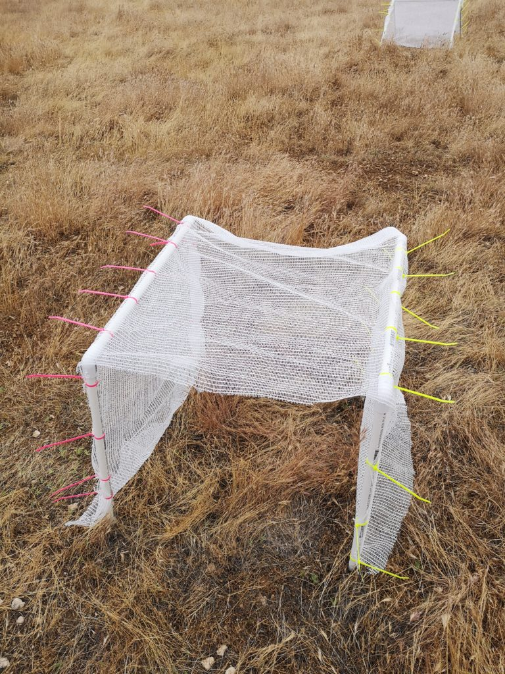**Figures & Tables**

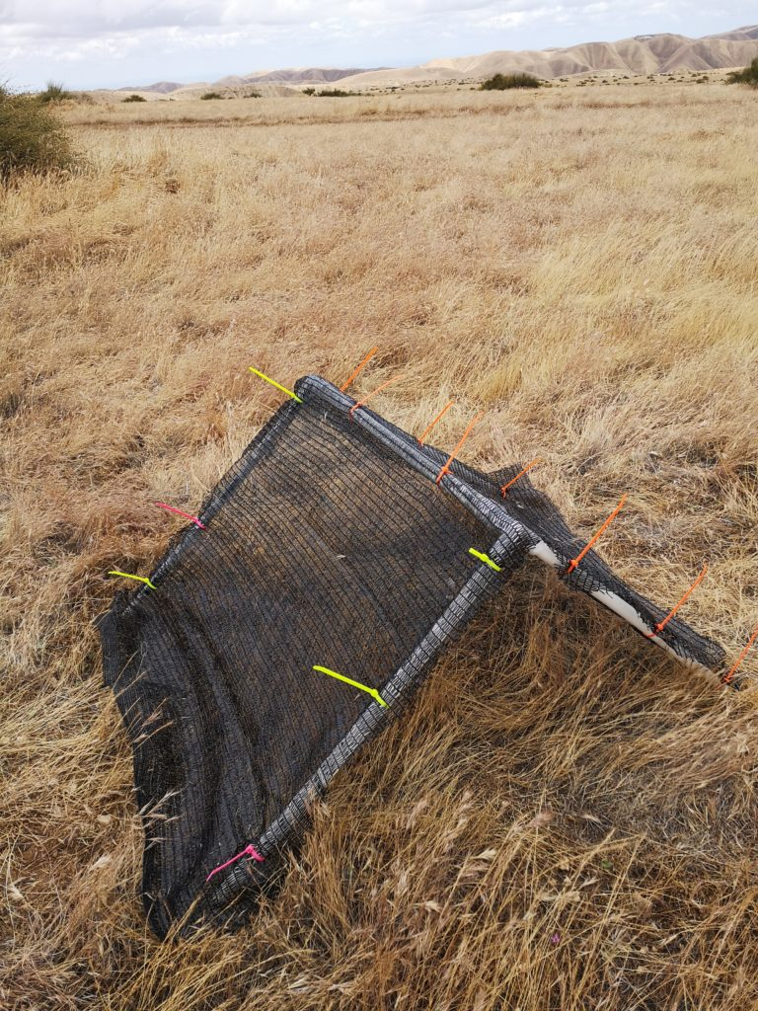

**Figure 1. Left-Triangular shelter with 90% shade cloth attached to PVC skeleton using zip ties. Right-Rectangular shelter with 15% shade cloth attached to two PVC skeletal frames.**

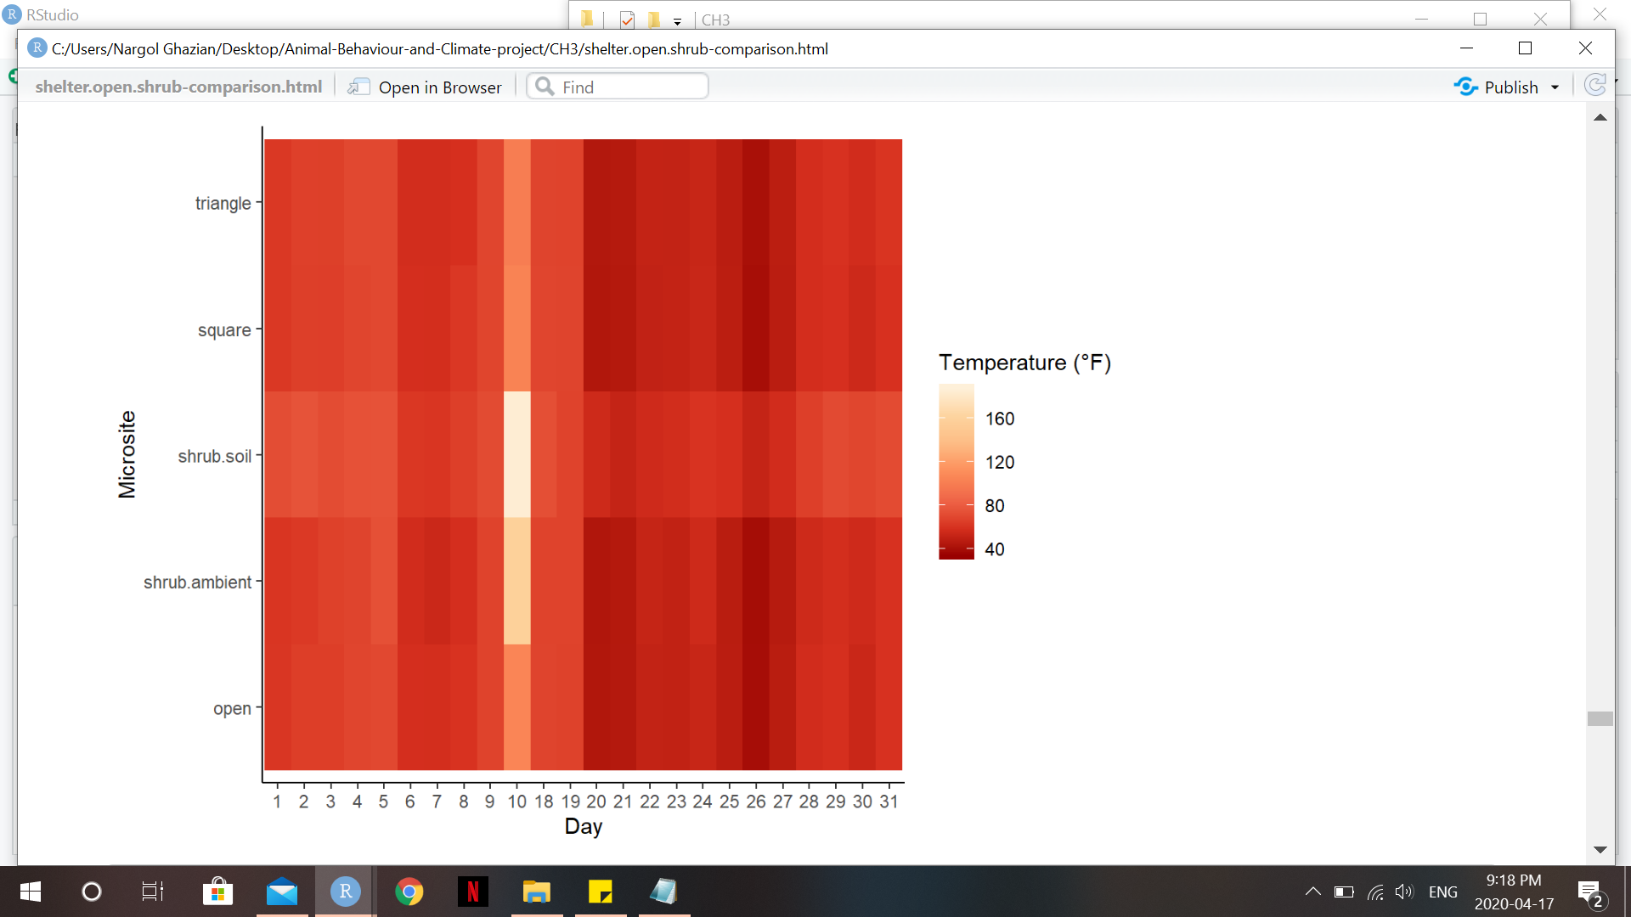

**Figure 2. Heat Map visualizing temperature (°F) during the study period at the different microsites. Darker red colours corresponds to cooler temperature whilst bright yellow colours correspond to warmer temperatures.**

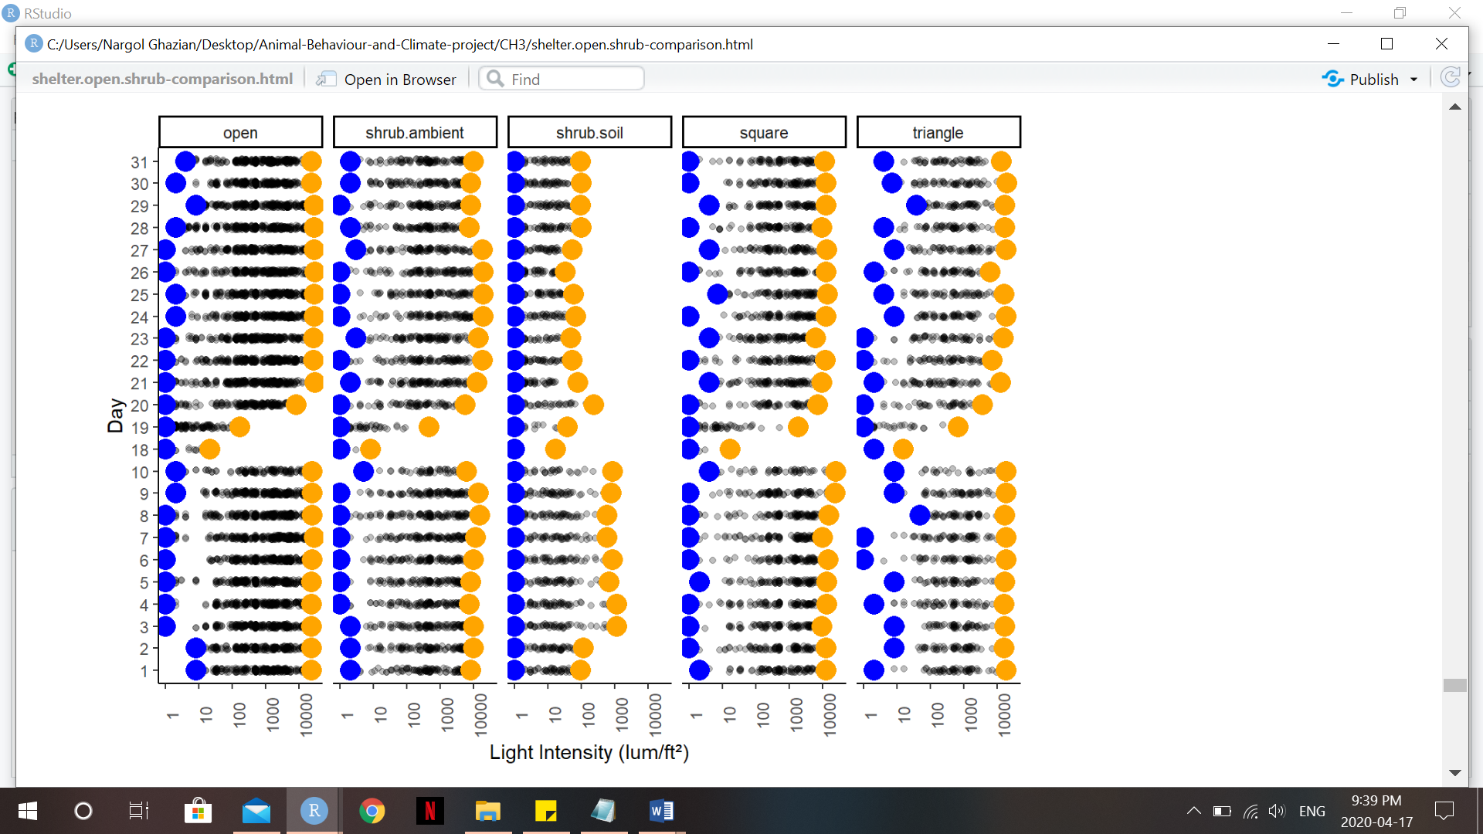**Figure 3. Scatter plot (Jitter plot) showing light intensity (lum/ft2) over the duration of the study period at each microsite. Yellow dots represent maximum intensity, while blue dots represent minimum intensity experienced during each day.**

**Table 1. Generalized Linear Model (GLM) for predicting temperature. 95% Confidence Intervals are provided along with the p-value for each microsite. Significant p-values (p<0.05) are bolded.**

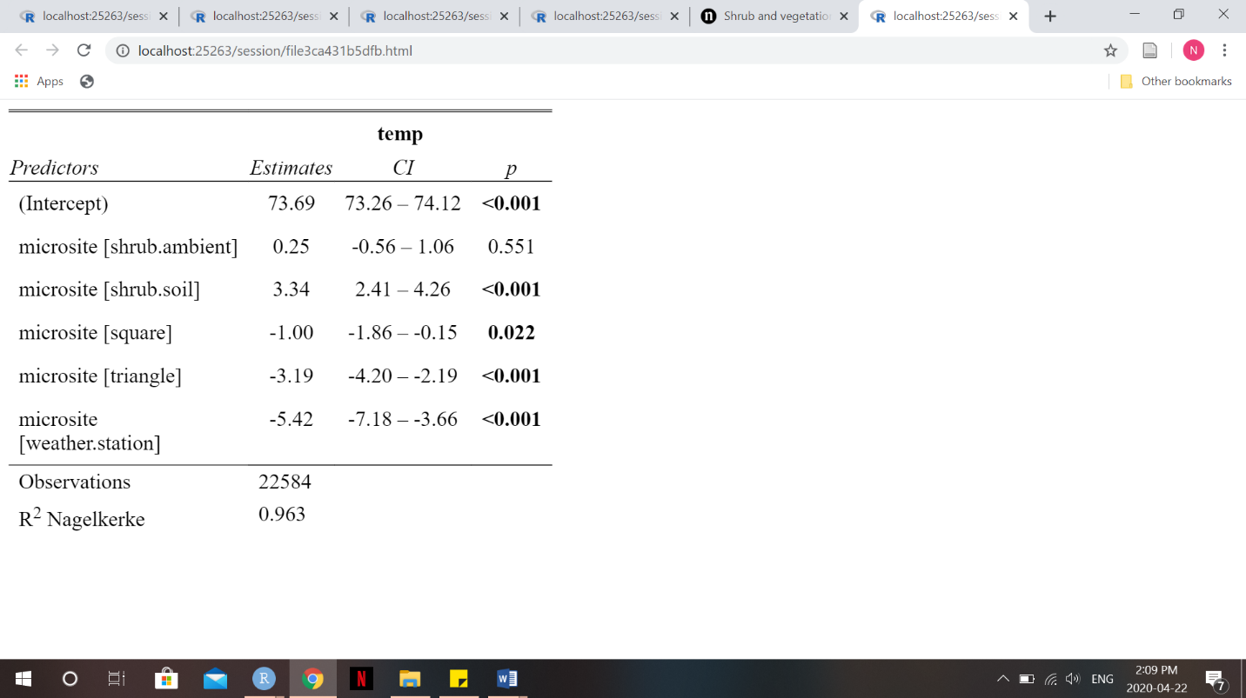

**Table 2. Estimated Marginalized Mean (EMM) and standard error (SE) are given for each microsite based on temperature GLM. Confidence Interval used is 95%.**

|  |  |  |  |  |
| --- | --- | --- | --- | --- |
| **Microsite** | **emmean** | **SE** | **Asymp.LCL** | **Asymp.UCL** |
| open | 73.7 | 0.219 | 73.3 | 74.1 |
| shrub.ambient | 73.9 | 0.351 | 73.2 | 74.6 |
| shrub.soil | 77.0 | 0.417 | 76.2 | 77.8 |
| square | 72.7 | 0.378 | 71.9 | 73.4 |
| triangle | 70.5 | 0.463 | 69.6 | 71.4 |
| weather.station | 68.3 | 0.872 | 66.6 | 70.0 |
| **Microsite Pr(>Chisq)= 0.0001** | | | | |

**Table 3. Pairwise analysis of microsites based on temperature GLM. Standard error and p-values are given. Significant p-values are bolded.**

|  |  |  |  |  |
| --- | --- | --- | --- | --- |
| **Contrast** | **estimate** | **SE** | **z.ratio** | **p-Value** |
| open-shrub.ambient | -0.247 | 0.414 | -0.597 | 0.9913 |
| open-shrub.soil | -3.337 | 0.471 | -7.077 | **0.0001** |
| open-square | 1.005 | 0.437 | 2.298 | 0.1947 |
| open-triangle | 3.195 | 0.512 | 6.238 | **0.0001** |
| open-weather.station | 5.42 | 0.899 | 6.029 | **0.0001** |
| shrub.ambient-shrub.soil | -3.09 | 0.545 | -5.665 | **0.0001** |
| shrub.ambient-square | 1.252 | 0.516 | 2.426 | 0.1473 |
| shrub.ambient-triangle | 3.442 | 0.581 | 5.952 | **0.0001** |
| shrub.ambient-weather.station | 5.667 | 0.94 | 6.030 | **0.0001** |
| shrub.soil-square | 4.342 | 0.563 | 7.708 | **0.0001** |
| shrub.soil-triangle | 6.532 | 0.623 | 10.480 | **0.0001** |
| shrub.soil-weather.station | 8.757 | 0.967 | 9.059 | **0.0001** |
| square-triangle | 2.19 | 0.598 | 3.664 | **0.0034** |
| square-weather.station | 4.415 | 0.95 | 4.646 | **0.0001** |
| triangle-weather.station | 2.225 | 0.987 | 2.254 | 0.2131 |

**Table 4. Generalized Linear Model (GLM) for predicting light intensity. 95% Confidence Intervals are provided along with the p-value for each microsite. Significant p-values (p<0.05) are bolded.**

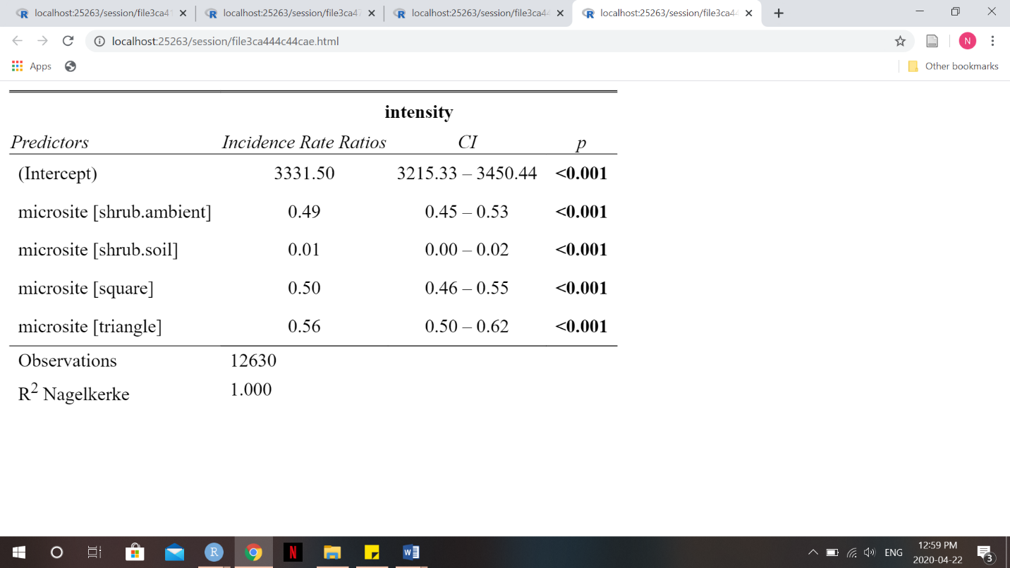

**Table 5. Estimated Marginalized Mean (EMM) and standard error (SE) are given for each microsite based on light intensity GLM. Results are given on the log scale and Confidence Interval used is 95%.**

|  |  |  |  |  |
| --- | --- | --- | --- | --- |
| **Microsite** | **emmean** | **SE** | **Asymp.LCL** | **Asymp.UCL** |
| open | 8.111 | 0.018 | 8.076 | 8.146 |
| shrub.ambient | 7.395 | 0.04146 | 7.314 | 7.476 |
| shrub.soil | 3.522 | 0.4142 | 2.711 | 4.334 |
| square | 7.424 | 0.04371 | 7.338 | 7.51 |
| triangle | 7.529 | 0.05124 | 7.429 | 7.63 |
| **Microsite Pr(>Chisq)= 0.0001** | | | | |

**Table 6. Pairwise analysis of microsites based on light intensity GLM. Standard error and p-values are given. Significant p-values are bolded and confidence level used is 95%. Results are given on the log scale.**

|  |  |  |  |  |
| --- | --- | --- | --- | --- |
| **Contrast** | **estimate** | **SE** | **z.ratio** | **p-Value** |
| open-shrub.ambient | 0.7161 | 0.0452 | 15.842 | **0.0001** |
| open-shrub.soil | 0.5889 | 0.4146 | 11.068 | **0.0001** |
| open-square | 0.6873 | 0.0473 | 14.539 | **0.0001** |
| open-triangle | 0.5821 | 0.0543 | 10.718 | **0.0001** |
| shrub.ambient-shrub.soil | 3.8728 | 0.4163 | 9.304 | **0.0001** |
| shrub.ambient-square | -0.0287 | 0.0602 | -0.477 | 0.9895 |
| shrub.ambient-triangle | -0.134 | 0.0659 | -2.032 | 0.2505 |
| shrub.soil-square | -0.9015 | 0.4165 | -9.367 | **0.0001** |
| shrub.soil-triangle | -4.0068 | 0.4174 | -9.600 | **0.0001** |
| square-triangle | -0.1052 | 0.0674 | -1.562 | 0.5218 |

**Supplementary Appendix**

**A. A list of PVC pieces used for shelter skeleton construction is provided alongside the quantity needed to build one of each shelter-type.**

|  |  |  |
| --- | --- | --- |
| **Piece** | **Quantity for Triangular Shelter** | **Quantity for Rectangular Shelter** |
| 61 cm (½ inch diameter) pipe | 4 | 4 |
| 61 cm (¾ inch diameter) pipe | NA | 2 |
| 75 ¾ cm pipe | 1 | NA |
| ½ inch to ¾ inch adapter | 2 | NA |
| ½ inch to ¾ inch 2-way 90º elbow | NA | 4 |
| ½ inch 3-way 90º elbow | 2 | NA |

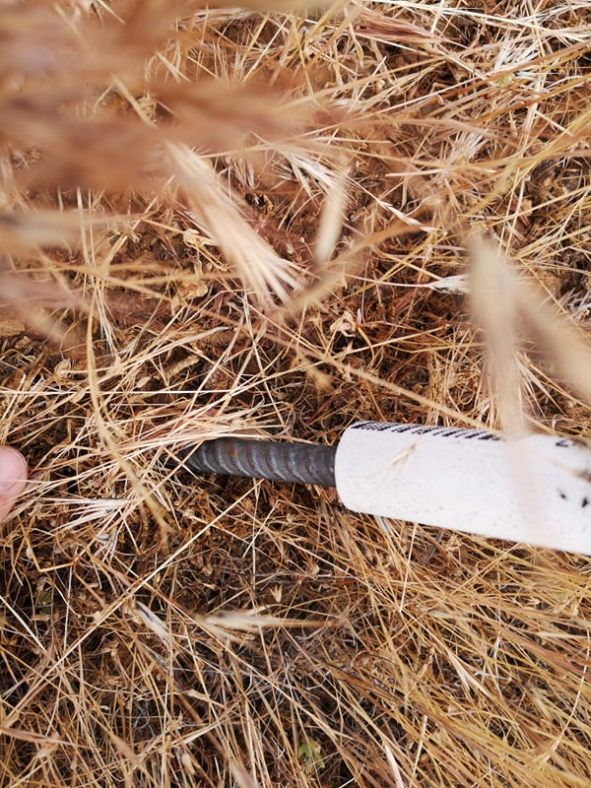

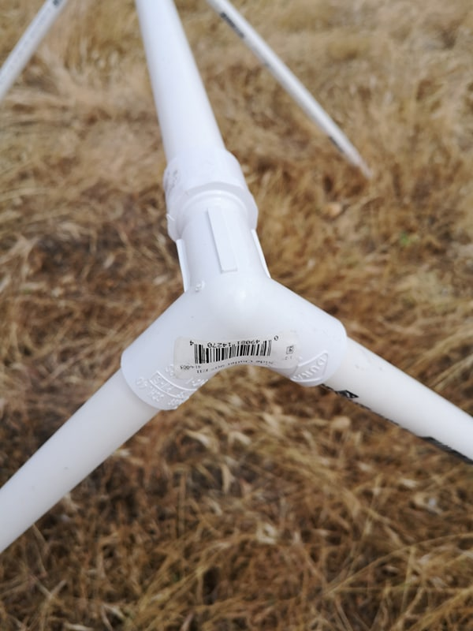

**B. Left- General PVC triangular structure and joint. Right-Metal stake and with PVC pipe slid on.**

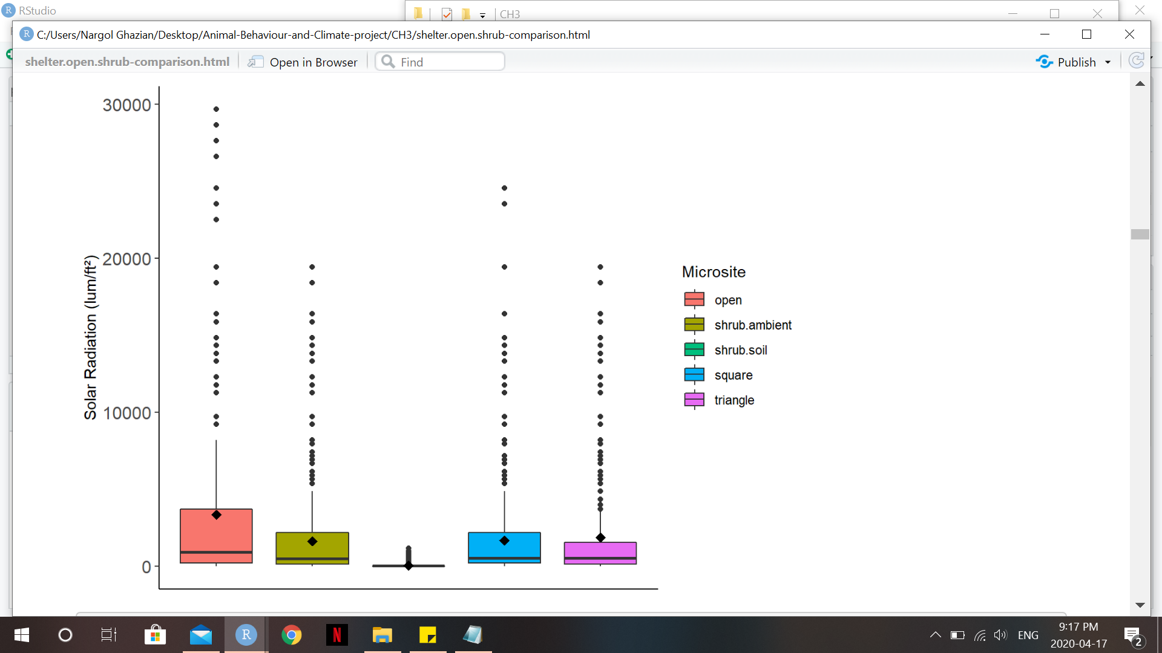**C. Box plot showing temperature (°F) at each microsite. Solid middle lines shows the median of the data, whilst whiskers show 1.5 standard deviation. Solid dots are outliers >1.5 interquartile range (IQR). Diamonds dots represent the mean.**

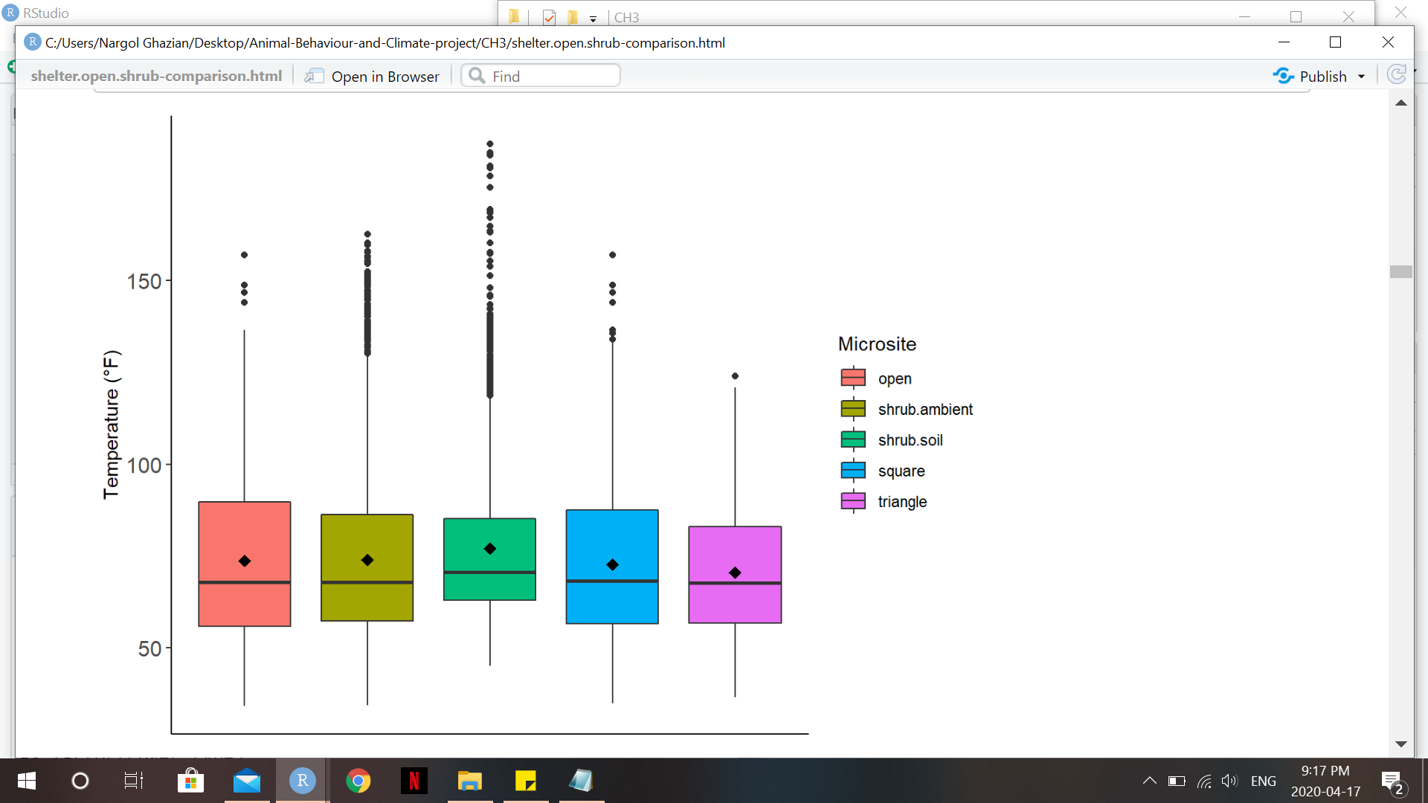

**D. Box plot showing light intensity (lum/ft2) at each microsite. Solid middle lines shows the median of the data, whilst whiskers show 1.5 standard deviation. Solid dots are outliers >1.5 interquartile range (IQR). Diamonds dots represent the mean.**

**E. Pairwise contrast of temperature at different microsites by cover type. Results are given at 95% CI. Significant p-values are bolded.**

|  |  |  |  |  |  |
| --- | --- | --- | --- | --- | --- |
| **Cover Type** | **Contrast** | **estimate** | **SE** | **z.ratio** | **p-Value** |
| 0 | Open-triangle | -26.593 | 21.532 | -1.235 | 0.4324 |
| 15 | Square-triangle | 1.031 | 1.126 | 0.916 | 0.6301 |
| 50 | Square-triangle | 0.584 | 1.123 | 0.52 | 0.8616 |
| 90 | Square-triangle | 3.527 | 3.527 | 3.853 | **0.0003** |
| **Microsite Pr (>Chisq)= 0.0001**  **Cover Pr (>Chisq)=0.0001** | | | | | |

**F. Pairwise contrast of light intensity at different microsites by cover type. Results are given at 95% CI on the log scale. Significant p-values are bolded.**

|  |  |  |  |  |  |
| --- | --- | --- | --- | --- | --- |
| **Cover Type** | **Contrast** | **estimate** | **SE** | **z.ratio** | **p-Value** |
| 0 | Open-triangle | -0.267 | 1.293 | -0.207 | 0.9767 |
| 15 | Square-triangle | -0.893 | 0.102 | -8.746 | **0.0001** |
| 50 | Square-triangle | 0.477 | 0.195 | 2.454 | **0.0376** |
| 90 | Square-triangle | 0.619 | 0.129 | 4.779 | **0.0001** |
| **Microsite Pr (>Chisq)= 0.0001**  **Cover Pr (>Chisq)=0.0001** | | | | | |

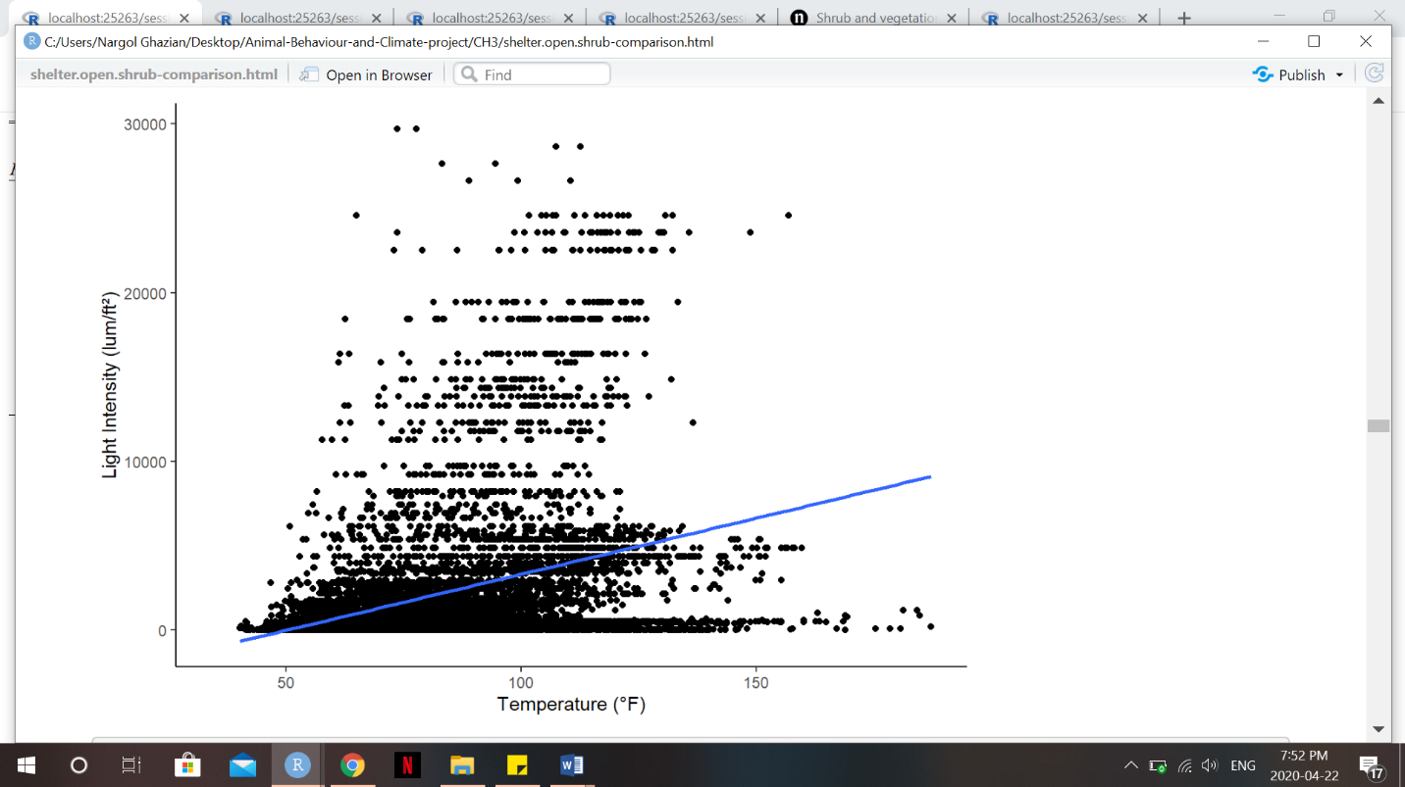

**G. Scatterplot showing the relationship between light intensity (lum/ft2) and temperature (°F). Blue line represents smooth conditional mean (Kendall’s tau=0.281, p=0.0001).**

**H. Location (latitude and longitude coordinates) of each shelter-open microsite is given, alongside its shape and cover type.**

|  |  |  |  |  |
| --- | --- | --- | --- | --- |
| **Shelter ID** | **Latitude** | **Longitude** | **Shape (Triangle/Square)** | **Cover type** |
| 1 | 36.69363 | -120.79318 | T | 15% |
| 2 | 36.69364 | -120.79331 | S | 15% |
| 3 | 36.69355 | -120.79315 | S | 90% |
| 4 | 36.69349 | -120.79320 | T | 90% |
| 5 | 36.69349 | -120.79311 | T | 50% |
| 6 | 36.39342 | -120.79311 | S | 50% |
| 7 | 36.69394 | -120.79300 | S | 15% |
| 8 | 36.69397 | -120.79292 | T | 15% |
| 9 | 36.69401 | -120.79282 | S | 90% |
| 10 | 36.694 | -120.79295 | T | 90% |
| 11 | 36.69405 | -120.79305 | S | 50% |
| 12 | 36.69408 | -120.79301 | T | 50% |

**I. Location (latitude and longitude coordinates) of shrub microsites.**

|  |  |  |
| --- | --- | --- |
| **Shrub ID** | **Latitude** | **Longitude** |
| 1 | 36.69532 | -120.797 |
| 2 | 36.69592 | -120.797 |
| 3 | 36.69533 | -120.794 |
| 4 | 36.69598 | -120.797 |
| 5 | 36.69591 | -120.797 |
| 6 | 36.69605 | -120.797 |
| 7 | 36.69595 | -120.798 |

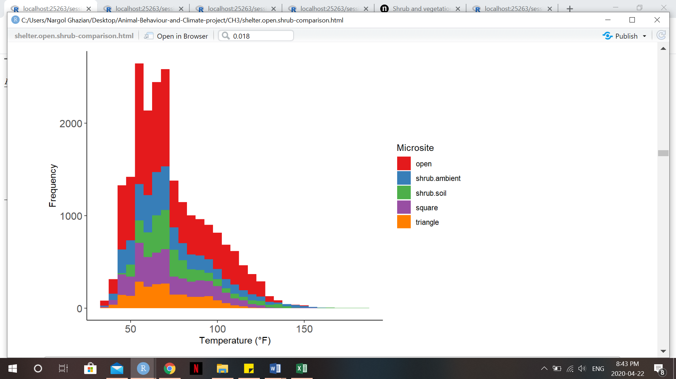

**J. Frequency histogram of temperatures (°F) recorded at each microsite. Higher temperatures were recorded at a greater frequency in the open.**